Association of scholarships with the number of care leavers studying at Aston

Aston’s Access and Participation Plan (2025-9) has targets to:
- Target 6 (PTS_5): Maintain current good continuation performance (where there are only minimal continuation gaps between IMD quintile 1 & 5) against challenging cost-of-living context through enhancement and targeting of our scholarships offering to those most in need.
One of the groups that we consider to be in need, is students classified as care leavers. We also aim to increase the number of students classed as care leavers that study with us. To achieve both objectives, we offer scholarships to eligible students worth £1,250 in each year of study. A theory of change model below illustrates how this is expected to increase and maintain enrolment of this group of students.
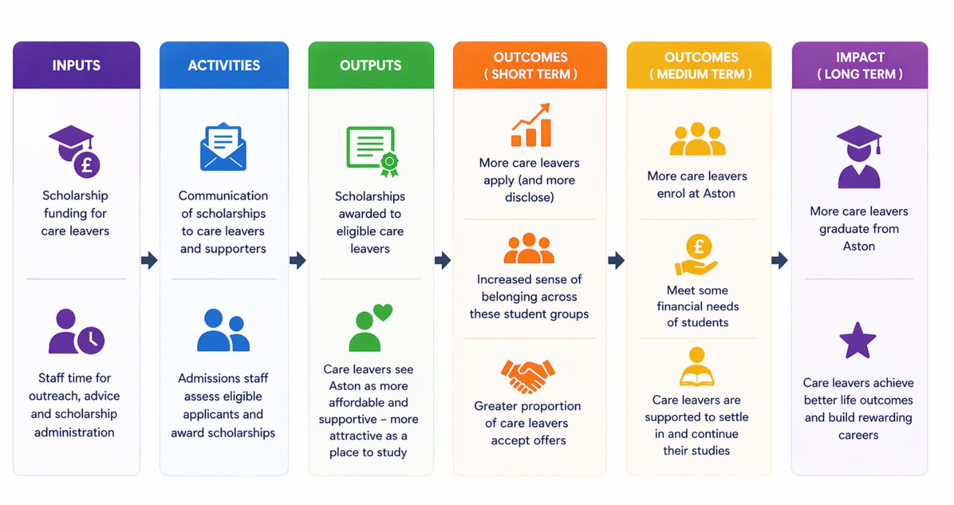
This short report examines whether Aston’s financial support for students who are care leavers is associated with the proportion and number of disclosed care leavers studying at Aston. Over the last decade, the value of the care leaver scholarship has changed; this provides an opportunity to describe how the recorded number and proportion of care leavers vary across years with different scholarship amounts. This analysis is descriptive and tests association; it does not, on its own, establish that scholarship changes caused changes in care leaver enrolment and disclosure.

Academic year | % care leavers | Number of care leavers | Total scholarship amount offered (excluding placement year)
2016/17 | 0.141 | 10 | 0
2017/18 | 0.383 | 26 | 500
2018/19 | 1.025 | 51 | 3750
2019/20 | 0.908 | 43 | 3750
2020/21 | 0.553 | 22 | 500
2021/22 | 0.820 | 38 | 3750
2022/23 | 0.777 | 38 | 3750
2023/24 | 0.974 | 57 | 3750
2024/25 | 1.716 | 123 | 3750
2025/26 | 1.046 | 63 | 3750
Table1. Showing the number and percentage of care leaver new entrants at Aston in the different academic years. Also shows the amount of scholarship offered to care leavers in each entry year. Highlighted in red are the years where the amount offered to care leavers was lower.
Table 1 shows lower recorded numbers/proportions of care leaver entrants in years where the scholarship amount offered was lower. The change in scholarship policy in 2020/21 corresponded to a decrease in care leavers studying at Aston after two years of it increasing. It is unclear what cause the increase in care leavers in 2024/5.

 | £0 Scholarship | £500 Scholarship | £3750 Scholarship
Care leaver (n) | 10 | 68 | 598
Not care leaver/ unknown (n) | 7,083 | 14,327 | 56,231
Table 2. Showing the number of Care leavers and non-care leavers studying at Aston in years in which different amounts of scholarship were offered to care leavers.
Table 2 shows that Care leaver status of new entry students is associated with the amount of scholarship in the year of entry. When the value of scholarship was higher, more care leavers started studying at Aston. This associated was tested and was significant ($χ^{2}$ =92.67, df=2, p<.001).

Conclusion:
Scholarship amount category is associated with recorded care leaver status; further work is needed to assess impact on continuation and belonging.

