Analyses of the impact of contextual offers at Aston University
Introduction
Aston’s Access and Participation Plan (2025-9) has targets to:
- Target 1.1 (PTA_1). Maintain the proportion of students accessing Aston University in receipt of FSM (currently 26%) through to 2028-29.
- Target 1.2 (PTA_2). Maintain the proportion of students accessing Aston University from an IMD Q 1-2 background (currently 65.8%) through to 2028-29.
- Target 2 (PTA_3). Increase the number of students progressing into Aston University who have declared a disability from 8.5% to 10.5% by 2028-29 through including disabled students within our contextual offer scheme and implementing the Disabled Students’ Commitment.
One of the ways Aston plans to do this is by employing contextual admissions. Contextual offers lower the offer grades to students meeting various eligibility criteria in order to acknowledge the context in which they achieve their qualifications. A theory of change model below illustrates how this is expected to increase and maintain enrolment of this group of students.
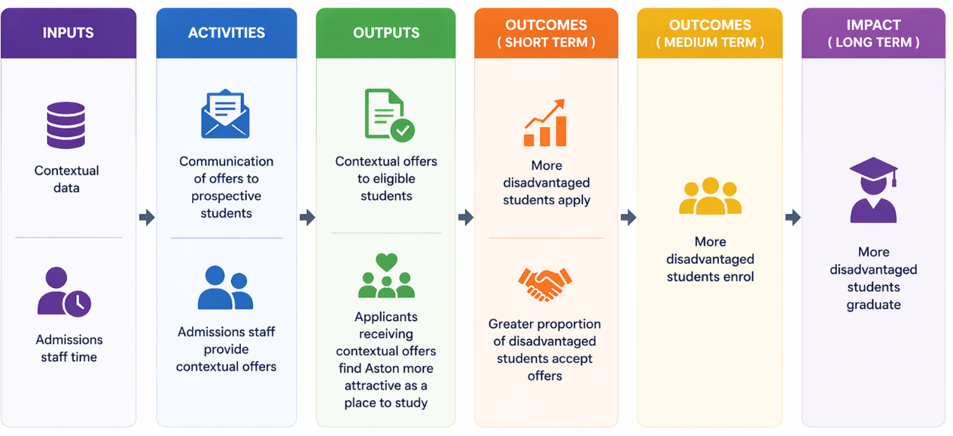
This paper presents an investigation of our theory of change. More specifically, of whether (i) applicants receiving contextual offers find Aston more attractive as a place to study when receiving a contextual offer, (ii) whether a greater proportion of students accept contextual offers vs. standard offers, and (iii) whether or not a greater proportion of students who receive contextual offers ultimately enrol onto Aston programmes. We also investigated (iv) the impact of contextual offers on FSM eligible enrolment and on enrolment of students declaring a disability.
i) Do applicants in targeted groups feel that their UCAS offer from Aston is more attainable and attractive?
Hypothesis: There will be a significant association between the type of offer an applicant receives (standard/ contextual/ unconditional) and how positively they feel about it (made Aston more appealing/ made Aston less appealing/ had no effect).
Method: Market research survey given to acceptors and decliners of Aston applicants (a different survey for each group). The survey was sent to around 20,391 applicants – all applicants that had responded at the time the survey was live. 1,571 responded (7% response rate), but not all completed all of the questions and some did not know what kind of offer that they had received.
Questions analysed for this evaluation included:
- For decliners: What type of offer did you receive from Aston University? For acceptors: What type of offer did you accept as your firm choice? And What type of offer did you accept as your insurance choice?
- How did the offer you received from Aston University affect your views on studying there? (options: had no effect/ made Aston more appealing/ made Aston less appealing)
- Demographic questions including sex, age and disability status

For the first question 2 variables were created to indicate:
- The applicant’s decision for Aston (firm/ decline/ insurance)
- The applicant’s offer received (standard/ contextual/ unconditional)

Data were omitted where students either did not respond, or did not know/ could not remember what kind of offer they had received

Results:
Results consisted of the numbers of people who were made each of three different offer types, their offer decision and their perception of their offer. The numbers of people in each category were analysed using chi square tests of association.

Offer type | Had no effect | Made Aston less appealing | Made Aston more appealing
Conditional | 354 (50.2%) | 70  (9.9%) | 281  (39.9%)
Contextual | 55 (32.0%) | 4  (2.3%) | 113  (65.7%)
Unconditional | 35 (50.0%) | 2  (2.9%) | 33  (47.1%)
Table 1. Showing the number of respondents to the survey who had received the different types of offer and how they felt about that offer. Percentages of respondents who felt different ways in each offer category are also shown.

Table 1 shows the number of respondents to the survey who had received each type of offer and how they felt about that offer. A greater proportion of those that received the contextual offer felt that their offer made Aston more appealing (65.7% vs. 39.9%). A chi square test of association showed a significant association between the type of offer received and the reported appeal of that offer (χ2=42.99, df=4, p<.001).

- Do applicants in targeted groups accept their UCAS offer more often?
Hypothesis: There will be a significant association between the type of offer an applicant receives (standard/ contextual/ unconditional) and their acceptance status (firm/ insurance/ decline)
Method: Admissions data were output from SITS for 2024-5. Data in the dataset included Aston’s initial decision (reject, unconditional offer, conditional offer) and whether any offer was contextual or non-contextual. It also included the applicants’ initial response (no response, decline, insurance or firm), domicile (UK or not), clearing status (yes/ no) and Aston’s confirmation decision (various options). It also included whether students achieved ABB+ grades or equivalent or not, Free School Meals status, Disability status and sex. We excluded data from non-UK based students, students who were rejected by Aston, and students who applied via clearing.
Results:
 | No response | Decline | Firm | Insurance
Contextual Offer | 7 (0.1%) | 2694 (46.9%) | 1483 (25.8%) | 1566 (27.2%)
No Contextual Offer | 791 (7.3%) | 5410 (49.9%) | 2741 (25.3%) | 1903 (17.5%)
Table 2. Showing the number of applicants in 2024-5 who had received the different types of offer and their decision on that offer.
Table 2 shows the number of applicants in 2024-5 who had received each type of offer and their initial decision status. A greater proportion of those that received the contextual offer are in the insurance category, rather than declining their offer. Interestingly, this group were also less likely to not respond to their offer at all. A chi square test of association showed a significant association between the type of offer received and the decision for that offer (χ2=578.12, df=3, p<.001).

- Do a greater proportion of students who receive contextual offers ultimately enrol onto Aston programmes?
Hypothesis: There will be a significant association between the type of offer an applicant receives (standard/ contextual/ unconditional) and their enrolment status (yes/no)
Method: as above
Results:
 | Enrolled | Not enrolled
Contextual Offer | 1050 (18.3%) | 4700 (81.7%)
No Contextual Offer | 1872 (17.3%) | 8973 (82.7%)
Table 3. Showing the number of applicants in 2024-5 who had received the different types of offer and whether or not they ultimately enrolled.
Table 3 shows that 18.3% of those given a contextual offer ultimately enrolled vs. 17.3% of those given a standard offer. A chi square test of association showed no significant association between the type of offer received and the enrolment for that offer (χ2=2.59, df=1, p=.108). Note that this analysis includes all those given offers, regardless of whether or not they accepted them. This analysis was repeated split by applicant decision type (firm/ insurance/ reject). Amongst those who made Aston firm, those with contextual offers were less likely to enrol than those with standard offers (51.1% vs. 59.9%: (χ2=30.07, df=1, p<.001). Further analysis showed that these students were more likely to be rejected by Aston at confirmation (29.7% vs. 25.1%, χ2=10.20, df=1, p<.01). Amongst those choosing Aston as insurance those receiving contextual offers are significantly more likely to enrol (18.6% vs. 11.5%: χ2=34.85, df=1, p<.001). Not surprisingly, those that decline us end up enrolled extremely rarely.
Note that ABB+ applicants behave differently to those with lower grades. Non-ABBs firm Aston at a similar rate regardless of type of offer (the difference is seen in insurance choices). ABB+ applicants are both more likely to put Aston as insurance AND less likely to put Aston as firm.
- Overall impact of contextual offers on FSM eligible enrolment and on enrolment of students declaring a disability
Patterns across FSM eligible students and students declaring a disability were similar to the main cohort (they more likely to choose Aston as insurance when receiving a contextual offer). Type of offer had no association with enrolment status in FSM eligible students. Amongst students declaring a disability those who did not receive a contextual offer were more likely to enrol (18.2% vs. 14.6%).
The proportion of students enrolled who had declared a disability was remarkably similar across 2024 vs. 2025 (15.7% vs. 16%: χ2<1) although the absolute numbers were larger in 2025 (293 vs. 351). The proportion of students enrolled who had declared FSM eligibility was also remarkably similar across 2024 vs. 2025 (20.2% vs. 19.6%: χ2<1), although the absolute numbers were larger in 2025 (782 vs. 887).
Conclusion: This evaluation set out to assess whether contextual offers at Aston University widen access by increasing applicant engagement, acceptance, and enrolment among targeted groups. Taken together, the findings indicate that contextual offers achieve important behavioural and perceptual effects, but do not increase firm acceptances or overall enrolment rates in isolation.

Across both survey and admissions datasets, contextual offers are consistently perceived as more appealing than standard offers, and applicants receiving them are less likely to disengage or decline Aston outright. In particular, contextual offers are associated with a reduction in non-response and decline, and a corresponding increase in applicants choosing Aston as their insurance choice, rather than as their firm choice. These patterns are observed both in self-reported perceptions and in actual UCAS decision data, strengthening confidence in their robustness.

Among those who do make Aston their firm choice, applicants holding contextual offers are less likely to enrol than those holding standard offers, and are at greater risk of rejection at confirmation stage. In contrast, applicants holding contextual offers who place Aston as their insurance choice are significantly more likely to enrol than comparable applicants with standard offers. Taken together, these findings suggest that contextual offers at Aston function primarily as a risk-mitigation and safety-net mechanism, supporting enrolment through insurance conversion and reducing total attrition from the applicant pool, rather than acting as a driver of firm choice. This is consistent across attainment bands and demographic subgroups examined, including FSM-eligible and disabled applicants.

In policy terms, contextual offers should therefore be understood as a component of a portfolio of access and participation measures, effective in sustaining applicant engagement and supporting enrolment pathways, but insufficient on their own to increase firm acceptances.

